Pupil premium strategy statement – South Bank Primary School
This statement details our school’s use of pupil premium funding to help improve the attainment of our disadvantaged pupils.
It outlines our pupil premium strategy, how we intend to spend the funding in this academic year and the outcomes for disadvantaged pupils last academic year.

School overview
Detail | Data
Number of pupils in school | 307
Proportion (%) of pupil premium eligible pupils | 60% 181/307
Academic year/years that our current pupil premium strategy plan covers (3 year plans are recommended – you must still publish an updated statement each academic year) | 2024 - 25  2025 – 26  2026 - 27
Date this statement was published | 25 Nov 2025
Date on which it will be reviewed | Dec 2026
Statement authorised by | Tammy Cooper
Pupil premium lead | Charmaine Burgess
Governor / Trustee lead | Craig Nicholls

Funding overview
Detail | Amount
Pupil premium funding allocation this academic year | £261,400
Pupil premium funding carried forward from previous years (enter £0 if not applicable) | £0
Total budget for this academic year  If your school is an academy in a trust that pools this funding, state the amount available to your school this academic year | £261,400

Part A: Pupil premium strategy plan

Statement of intent
- What are your ultimate objectives for your disadvantaged pupils?
- How does your current pupil premium strategy plan work towards achieving those objectives?
- What are the key principles of your strategy plan?

Our intention is that all pupils, irrespective of their background or the challenges they face, make good progress and achieve high attainment across all subject areas.

Teaching and learning will be at the forefront of the strategy with the focus being on recruiting and retaining high quality teachers who ensure outcomes are improved through the delivery of quality first teaching and targeted intervention. Continuing Professional Development for teachers and leaders will support the delivery of an ambitious, inclusive curriculum across school in which all pupils are able to make good progress.

The progress of disadvantaged pupils will be monitored closely with a focus on ensuring high outcomes through a responsive approach to academic and personal development needs. Our approach will continue to be responsive to the needs of the local community, ensuring that individual needs are met and challenges are approached using robust evidence based practice.

Attendance will be further focus of this strategy with a focus on reducing the level of overall absence and the number of persistent absentees.

Challenges
This details the key challenges to achievement that we have identified among our disadvantaged pupils.
Challenge number | Detail of challenge
1 | IDACI  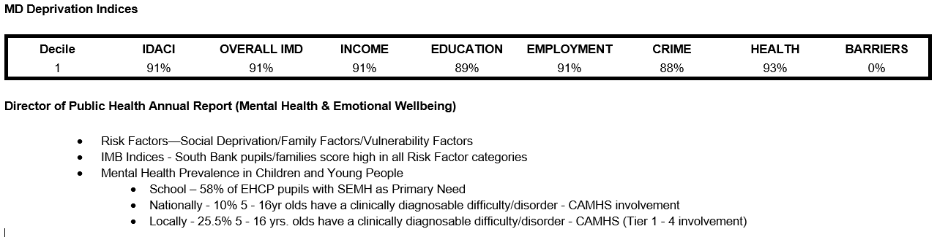
2 | Oral language skills and vocabulary gaps  Assessment, observation and discussion with pupils indicate significantly under developed oral language skills and vocabulary gaps for a significant proportion of pupils with a general trend of a higher prevalence in disadvantaged pupils.  EEF – There is evidence to suggest that pupils from lower socioeconomic backgrounds are more likely to be behind their more disadvantaged counterparts in developing early language and speech skills, which may affect their school experience and learning later in their school lives.  Given that oral language interventions can be used to provide additional support to pupils who are behind their peers in oral language development, the targets use of approaches may support some disadvantaged pupils to catch up with peers, particularly when this is provided one-to-one.
3 | Phonics  RWI programme is embedded and delivered from Nursery up to year 4 (where appropriate). Phonics screening results are currently below national data.  Baselines in communication and language in Early Years identify significantly low starting points.  EEF - It is possible that some disadvantaged pupils may not develop phonological awareness at the same rate as other pupils, having been exposed to fewer words spoken and books read in the home.
4 | Maths  Power Maths is adopted across school and school are working with the Maths Hub to improve progress and attainment. Mastering Number from the Maths Hub has been adopted as whole class teaching in EYFS and as an intervention in Year 1 and 2 classes.  Mastering Number: ‘This project aims to secure firm foundations in the development of good number sense for all children from Reception through to Year 1 and Year 2. The aim over time is that children will leave KS1 with fluency in calculation and a confidence and flexibility with number.’  Percentage of children achieving expected levels decreased in 2023-24, with percentage below national expectations.  EYFS baselines highlight low starting points:
5 | English  Reading and writing curriculum and outcomes are high priority with data outcomes for 2024-25 below national expectations. This is a whole school focus in order to improve outcomes.  EYFS baselines highlight low starting points in all areas:
6 | SEMH  Assessments, observations and discussion with pupils and their families identify a significant rate of social, emotional and mental health difficulties affecting those from disadvantaged backgrounds in school. Home visits on entry to school indicate the need for further family support to be provided.  Behaviour logs indicate need for family support for several pupils with significant social, emotional and mental health difficulties.  Baseline on entry to Reception highlight pupils low starting points in this area:
7 | Social Service Involvement/ Parental engagement  Social service involvement is at a significantly high percentage of school population, this is at tier 1,2 and 3 level.  Parental engagement is inconsistent across school with many families disengaged from education due to poor previous experiences, cultural expectations and lack of experience of further education.  EEF - Disadvantaged pupils are less likely to benefit from having a space to conduct home learning. Evidence also suggests that disadvantaged pupils make less academic progress, and sometimes attainment levels even regress during the summer holidays, due to the level of formal and informal learning activities they do or do not participate in. By designing and delivering effective approaches to support parental engagement, schools and teachers may be able to mitigate some of these causes of educational disadvantage, supporting parents to assist their children’s learning or their self-regulation, as well as specific skills, such as reading.
8 | SEN  Rate of presence of SEN needs is significantly higher than in both the local authority and national statistics. Teacher identification can be a challenge due to pupils low starting points and often difficulties with social communication and emotional regulation on entry to school.  41% of pupils on roll are registered SEN.  18% pupils have an EHCP in place.  The ARP in school has increased in numbers from 25 places (Sept 2023) to 48 places (Sept 2024) with the majority of pupils presenting with significant complex needs.
9 | Attendance  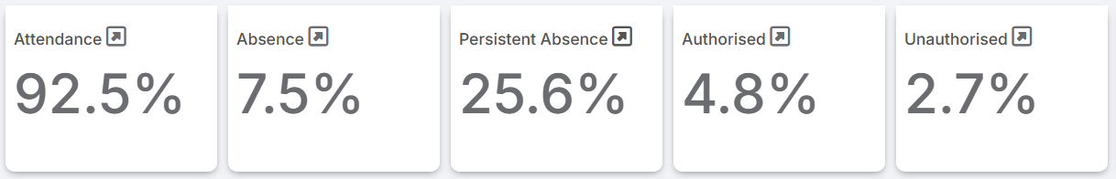  Attendance continues to be an ongoing area of challenge. School are currently working as part of a DfE and Local Authority pilot to address this.
10 | English as an additional language  Number of pupils with EAL stands at 28% which is above national average (National 20.8%).  There are currently 20 first languages other than English being spoken across school.
11 | Pupil numbers are increasing year on year with the number of in year transfers increasing significantly.  Places in the two and three year old nursery and in the ARP have also impacted on the increased number on roll.
12 | New staff (including ARP staff and Overstaffing)  Due to the increase in pupil numbers and focus on improving outcomes for pupils there has been a move to an over staffing model in school. This has added an additional four members of staff to the staffing team -three of these are current Early Career Teachers.
13 | Extension  Pupil number on roll attending the ARP has increased. This has had a significant impact on the space in school with all available rooms used for teaching spaces.  Due to the increasing complexity and numbers of pupils attending the ARP the environments have been significantly adapted. This includes a new build project to increase the school capacity by the addition of two new classrooms to create an ARP unit.

Intended outcomes
This explains the outcomes we are aiming for by the end of our current strategy plan, and how we will measure whether they have been achieved.
Intended outcome | Success criteria
To raise % of pupils achieving expected levels at the end of KS2 in reading and writing. | The number of pupils achieving expected levels at the end of KS2 shows an increase.
To raise % of pupils achieving expected levels at the end of KS2 in maths. | The number of pupils achieving expected levels at the end of KS2 shows an increase.
To raise phonics standards to be in line with national expectations. | The number of pupils achieving a pass in the KS1 phonics screening is in line with national expectations.
The gap between outcomes for disadvantaged pupils and non-disadvantaged pupils narrows. | There is a decrease year on year in the gap between the outcomes of disadvantaged pupils and non-disadvantaged pupils.
Improve oral language skills and vocabulary. | Pupils show significant improvement in their oral language skills which impacts positively on all areas of the curriculum.
To achieve and sustain improved attendance for all pupils, particularly our disadvantaged pupils. | Engagement in Dfe/LA joint commissioned project Making Attendance Everyone’s Business.  Attendance outcomes for all pupil groups are improving through the monitoring and intervention by both internal and external processes.  Number of SA pupils is reduced.
To achieve and sustain well-being for all pupils in our school, particularly those who are disadvantaged. | The behaviour of pupils continues to show improvement with a reduction in the number of negative behaviours shown.  Feedback from pupil, staff and parent voice demonstrates the positive impact on the well-being of all pupils.

Activity in this academic year
This details how we intend to spend our pupil premium funding this academic year to address the challenges listed above.

Teaching (for example, CPD, recruitment and retention)
Budgeted cost: £203,875
Activity | Evidence that supports this approach | Challenge number(s) addressed
Senior Leadership Team dedicated leadership time, 1 day per week  KS2/maths lead  KS2L/music lead  KS1/English lead  EYFS lead  PD Lead and ITT lead mentor  T & L Lead  M & F Lead  £9816 x 7  = £68712 | Teaching and Learning:  Metacognition and self-regulation | EEF  Marking and Feedback:  Feedback | EEF  Phonics:  Phonics | EEF  Behaviour:  Behaviour interventions | EEF  Oracy:  Oral language interventions | EEF  Maths:  What Maths Hubs are doing | NCETM  Effective Professional Development | EEF | 1, 3, 4, 5, 7, 8, 11
Senior Leadership Team dedicated leadership time, 2 days per week – SEN  -SENDco/ARP lead  £19, 633 | Special Educational Needs in Mainstream Schools | EEF  Supporting SEND - GOV.UK | 1, 2, 6, 7, 8, 11, 12, 13
Overstaffing model – Quality First Teaching and intervention support  ECT2 JB (£31,650)  ECT2 AW (£31,650)  M6 – SA (£43,607)  £106,907 | ECT professional development and support:  Early Career Framework ECF - Early Career Development Programme | Best Practice Network  High-quality teaching | EEF | 1, 2, 3, 4, 5, 6, 8, 10, 11
Challenge Partners  -SLA £6500  -Headteacher x4days  £1280  -SENDCo x4 days  £753  £8533 | Effective Professional Development | EEF  Home | Challenge Partners | 1, 2, 3, 4, 5, 8, 10, 11, 12

Targeted academic support (for example, tutoring, one-to-one support, structured interventions)
Budgeted cost: £43,607
Activity | Evidence that supports this approach | Challenge number(s) addressed
Overstaffing model – Quality First Teaching and intervention support  M6 -recruitment (£43,607)  £43, 607 | Targeted academic support | EEF | 1, 2, 3, 4, 5, 6, 8, 10, 11

Wider strategies (for example, related to attendance, behaviour, wellbeing)
Budgeted cost: £6240
Activity | Evidence that supports this approach | Challenge number(s) addressed
Attendance SLA  £6240 | Working together to improve school attendance - GOV.UK | 1, 7, 9, 11

Total budgeted cost: £253,632Part B: Review of the previous academic year

Outcomes for disadvantaged pupils
Outline the performance of your disadvantaged pupils in the previous academic year and explain how it has been assessed. You should draw on:
- Data from the previous academic year’s national assessments and qualifications, once published.
- Comparison to local and national averages and outcomes achieved by your school’s non-disadvantaged pupils (a note of caution can be added to signal that pupils included in the performance data will have experienced some disruption due to Covid-19 earlier in their schooling, which will have affected individual pupils and schools differently).
- Information from summative and formative assessments the school has undertaken.
- School data and observations used to assess wider issues impacting
disadvantaged pupils’ performance, including attendance, behaviour and
wellbeing
You should state whether you are on target to achieve the outcomes of your strategy (as outlined in the Intended Outcomes section above) and outline your analysis of what aspects of your strategy are/are not working well.
If last year marked the end of a previous pupil premium strategy plan, you should set out your assessment of how successfully the intended outcomes of that plan were met.
Review of academic year 2024 - 25 outcomes, year 1 of the strategy plan:
2024 -25 marked the end of year one of the three year strategy plan. This links to the start of a new school improvement plan developed as a result of the outcomes of OFSTED inspection June 2024.
1 – Wellcomm is now embedded in key areas across school. 128 children accessed the intervention with all children making progress.
Members of SLT have engaged with Early Language Training delivered by the English Hub and an oracy and vocabulary strategy is currently in development with training delivered to all staff.

2 – Phonics screening outcomes

2025 Results
All children | Not including ARP |  |  | Homegrown only | Non – homegrown only
26/53 | 26/38 |  |  | 19/41 | 7/12
49% | 68% |  |  | 46% | 48%
2024 data
27/39 |  | 27/36 | 18/24 |  | 9/15
69% |  | 75% | 75% |  | 60%

A new SIP places high significance on development of the curriculum with a focus on the reading curriculum and progress in this area. This will continue to be a significant focus of the strategy developed for 2025-26.
GLD 2020 - 2025
2020 |  | 2021 |  | 2022 |  | 2023 |  | 2024 |  | 2025 *NEW*
With SB | Without SB | With SB | Without SB | With SB | Without SB | With SB | Without SB | With SB | Without SB | With SB | Without SB
COVID |  | COVD |  | 33%  8/24 | 38%  8/21 | 47%  15/32 | 48%  15/31 | 35%  17/48 | 52%  17/33 | 38%  20/52 | 54%  20/37

3 – Maths - Implementation of Power Maths, support and guidance from the Maths Hub, Daily 5 introduction and arithmetic days have all been put in place over the last 18 months to improve these outcomes. Refining this practice and ensuring it impacts directly on pupil outcomes will be a focus of the 2025-26 strategy.
4. The focus of the SEMH team has changed to recognise the changing needs of the school community. The team now focuses on early family intervention rather than direct work with children. Therefore, there has been a significant increase in the number of families the team works with.
KS2 outcomes remain below national expectations and focus on teaching and learning to improve outcomes will be key priority in new strategy 2025-26.
5. OFSTED June 2024 identifies school as ‘inclusive and welcoming’, ‘pupils behave well’ and ‘parents are positive about the whole school offer’. Feedback from pupils, parents and staff indicate that pupils and families/carers are well supported and well-being is promoted for all.

The number of children monitored for difficulties with behaviour in school has dropped from 15% to 9% showing a significant reduction in the number of pupils requiring additional support for behaviour. The introduction of a behaviour curriculum has ensured that behaviour is explicitly taught across school (two-year-olds – year 6) and consistency is applied is the adoption of the positive behaviour policy.

6. The school has IQM flagship status.

The ARP in school has increased in numbers from 25 places (Sept 2023) to 48 places (Sept 2024) with the majority of pupils presenting with significant complex needs.

The introduction of pathways for ARP provision has supported the development of appropriate curriculums for all pupils (including those with complex needs) and ensured that pupils with EHCP’s achieve high outcomes based on personalised targets drawn from EHCP and specialist agencies.

Due to the increasing complexity and numbers of pupils attending the ARP the environments have been significantly adapted. This includes a current build project to increase the school capacity by the addition of two new classrooms to create an ARP unit.

Parent feedback around provision is very positive and pupils make good progress from their starting points.

EHCP/SEN support in mainstream is good and pupils receive appropriate support. Staff receive regular training and support from the SENDCo and behaviour lead to ensure are pupils are ell supported to achieve high outcomes against their starting points.

7. Attendance
OFSTED June 2024 identified clear systems for improving attendance and recognised that the number of persistently absent pupils is reducing.

2024/2025

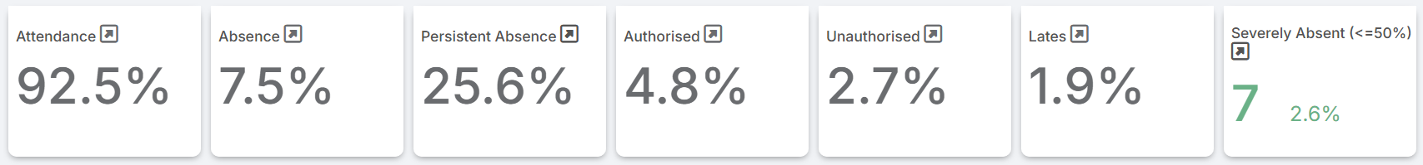

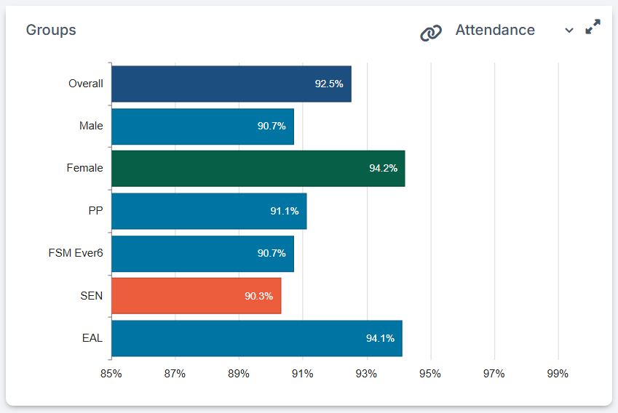

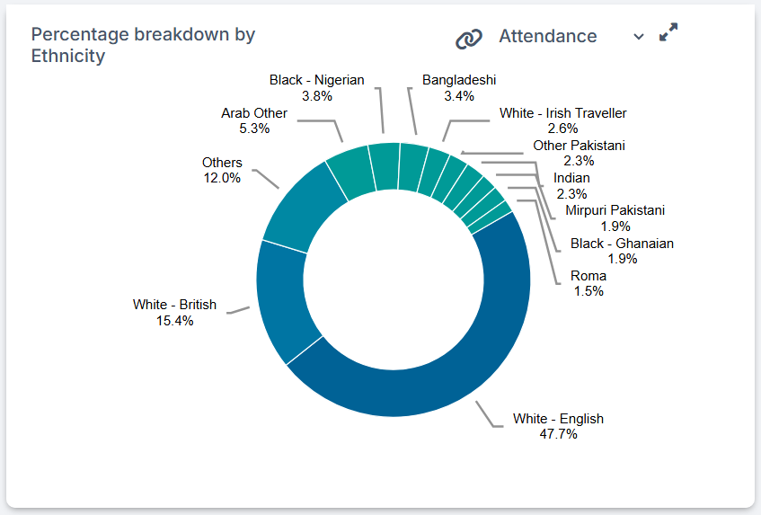

Externally provided programmes
Please include the names of any non-DfE programmes that you used your pupil premium to fund in the previous academic year.
Programme | Provider

Service pupil premium funding (optional)
For schools that receive this funding, you may wish to provide the following information: How our service pupil premium allocation was spent last academic year
The impact of that spending on service pupil premium eligible pupils

Further information (optional)
Use this space to provide any further information about your pupil premium strategy. For example, about your strategy planning, implementation and evaluation, or other activity that you are delivering to support disadvantaged pupils that is not dependent on pupil premium funding.

