

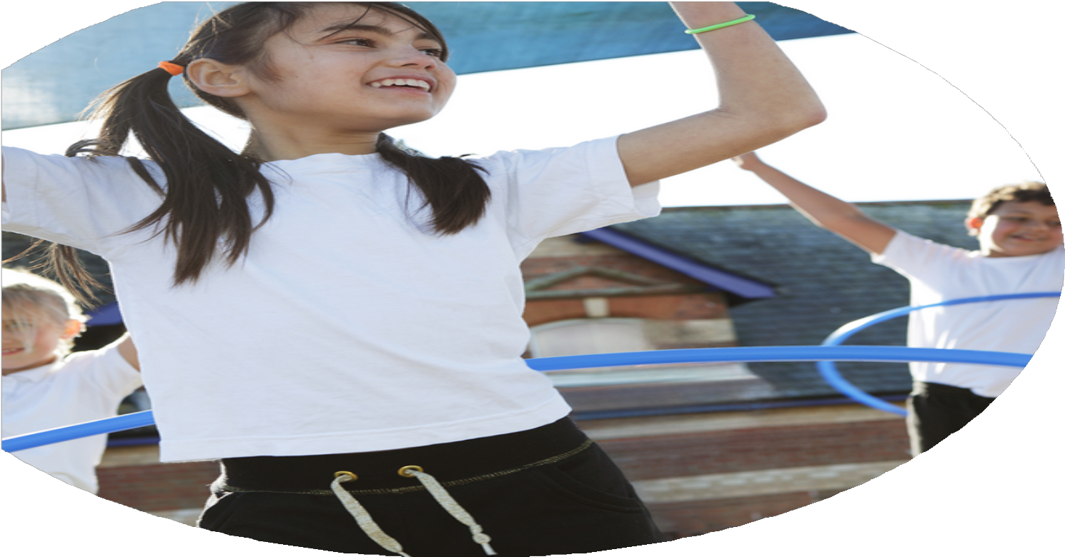
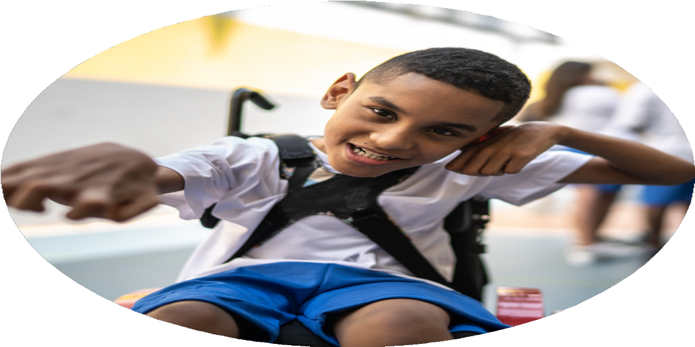
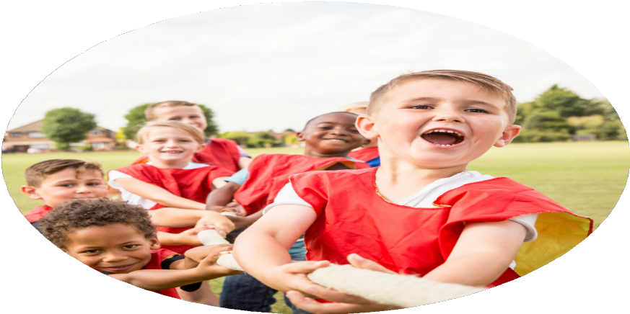



PE Funding

Evaluation Form

Commissioned by

Created by

Images courtesy of Youth Sport Trust

PE Funding Evaluation Form

It is intended that this template should be used as preparation for the completion of the statutory digital reporting tool being introduced this academic year. You can upload data (including swimming) from this template onto this platform once it becomes accessible.
Before you decide how you are going to use the funding for this academic year you should reflect and evaluate the impact of your use of the funding in 2023/24.
All spending of the funding must conform with the terms outlined in the Conditions of Grant document. The template is a working document that you can amend/update during the year.
Based on your evaluation of last year’s funding you should decide what you intend to do this academic year, how you will do it, and what impact you expect it to have.

It is important that the funding is used effectively and based on your school’s needs.
You must use the funding to make additional and sustainable improvements to the PE and sport in your school. You must develop and add to the PESSPA activities that your school already offers.

Summative digital reporting from June 2025 will continue to include swimming and water safety information therefore funding can be used to provide top-up lessons where necessary to ensure pupils meet national curriculum swimming requirements.

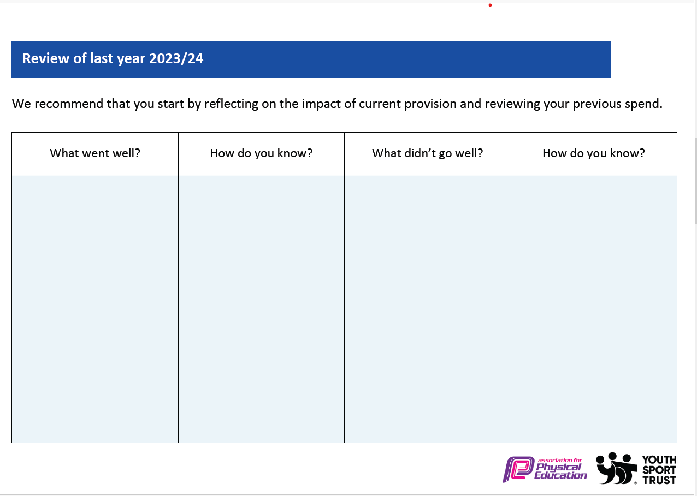
Staff self-reviews identified certain areas for development and that some individuals want further support. New staff have joined school this academic year.

Children became withdrawn at competitions if they were losing.
Top up swimming has helped to increase % of swimmers achieving 25m. Focus on year 5 swimming in addition to year 6 has seen significant increase in % for next academic year.

Festival successful – positive feedback from staff, parents, and children. This will now be an annual event.

Staff voice indicated positive impact on delivering and planning for PE.

Gold School Games Award achieved.
Pupil voice – enjoying a range of sports and taking part in competitions.

Children are ready for learning and are equipped with suitable clothing to have a successful PE lesson.

Children and staff now have more engaging lessons which result in higher outcomes as we have sufficient and high-quality equipment to deliver lessons.

Staff understanding of how to support complex needs pupils in developing their physical skills has increased significantly.
Additional top up swimming lessons

Sports festival

Staff CPD

Stronger links with SSP – competitions and development sessions attended by pupils across school.

PE Kits – all pupils.

Updated resources to match curriculum.

SEND – supporting complex needs pupils to access appropriate and inclusive PE/sport lessons and activities.

Not all staff are 100% confident teaching a range of sports and skills.

Children not having the resilience and motivation during competitions.
What are your plans for 2024/25?

Intent
How are you going to action and achieve these plans?

Implementation
- Staff self-review tools
- CPD throughout the year from specialist teachers such as dance, golf, MFC and team teaching through sports partnership.
- Links made with Tees Valley Sport
- Brand new after school clubs to run including football, dance, martial arts and golf.
- Sports festival week to run again this academic year to showcase multiple different sporting opportunities.
- Attend a minimum of 80% of the RESSP events.
- Ensuring children are appropriately prepared for events and events are chosen to suit their competence.
- Use RESSP virtual events packs to run intra competitions.
- Sports festival week
- Develop playtime activities and playtimes equipment.
- Continue to upskill Sports Leaders
- Promote active travel to and from school.
- Deliver parental engagement sessions – links made with creative active families officer.
- Wellbeing walks for parents/carers
- To ensure that all children receive a high-quality PE lesson each week and staff confidence in increased to deliver these lessons.

- Enhance our extra-curricular offering so children have the opportunity to experience a range of sports.

- Ensure there are multiple opportunities for all children in school to access competitions and build upon their resilience and determination.

- Increase children’s moderate to vigorous physical activity (MVPA) each day and engage parents to understand the importance and benefits.

What impact/intended impact/sustainability are you
expecting?
How will you know? What evidence do you have or
expect to have?
- Staff will complete PE self-review and will show an increase in confidence
- Pupil voice will show a higher engagement and enjoyment of PE.
- Lesson observations will show high quality PE lessons being taught.
- Assessment of PE with the use of Complete PE assessment
- High engagement and attendance to after school clubs
- Pupil voice that children are enjoying the afterschool clubs
- Pupil voice indicates positive attitudes towards PE, school sport and physical activity.
- Feedback from staff and children following events.
- Progress with School games mark.
- Activity levels using MOKI bands
- Attendance of parents/carers to workshops and events
- Parent/carer feedback
- High quality play during break times
- School staff to see an increase in children’s physical abilities.
- Staff feeling more confident to deliver high quality PE lessons
- Children more engaged and enjoying PE
- Sustainability: Staff confidence and competence to teach PE is sustainable
- Children develop a passion for sport
- Children identify a new sport that piques their interest
- Children become more engaged, fitter and healthier through the attendance and enjoyment of extra-curricular physical activities
- Children develop their physical education skills
- Sustainability: staff confidence and skills developed to continue to deliver extra-curricular sporting opportunities
- Children inspired and excited to take part in physical activities through competitions and events.
- Children develop life skills: determination, self-belief, teamwork, honesty, respect and passion.
- Children proud to represent their school.
- Sustainability: staff learning new activities at events and children becoming more confident and resilient individuals.
- Children becoming fitter, healthier, and more motivated.
- More engaged parents and understanding the importance of physical activity.
- More children walking to school.
- Sustainability: staff confidence and competence to deliver parent/carer workshops following CPD from family officer.

What impact/sustainability have you seen?
What evidence do you have?
- Staff completed PE self-review and will show an increase in confidence
- Pupil voice will show a higher engagement and enjoyment of PE.
- Lesson observations will show high quality PE lessons being taught.
- Assessment of PE with the use of Complete PE assessment
- High engagement and attendance to after school clubs
- Pupil voice that children are enjoying the afterschool clubs
- Pupil voice indicates positive attitudes towards PE, school sport and physical activity.
- Feedback from staff and children following events.
- Progress with School games mark.
- Activity levels using MOKI bands
- Attendance of parents/carers to workshops and events
- Parent/carer feedback
- High quality play during break times
- School staff to see an increase in children’s physical abilities.

- Staff feel more confident to deliver high quality PE lessons and make suitable adaptations to meet the needs of learners to ensure all children make progress.
- Children are more engaged and enjoying PE
- Sustainability: Staff confidence and competence to teach PE is sustainable
- Children develop a passion for sport
- Children identify a new sport that piques their interest
- Children become more engaged, fitter and healthier through the attendance and enjoyment of extra-curricular physical activities
- Children develop their physical education skills
- Sustainability: staff confidence and skills developed to continue to deliver extra-curricular sporting opportunities
- Children inspired and excited to take part in physical activities through competitions and events.
- Children develop life skills: determination, self-belief, teamwork, honesty, respect and passion.
- Children proud to represent their school.
- Sustainability: staff learning new activities at events and children becoming more confident and resilient individuals.
- Children becoming fitter, healthier, and more motivated.
- More engaged parents and understanding the importance of physical activity.
- More children walking to school.
- Sustainability: staff confidence and competence to deliver parent/carer workshops following CPD from family officer.

