Transition from Early Years to Year 1
All members of the school leadership team appreciate the significance of high-quality EYFS teaching and learning in raising achievement in Year 1 and beyond. Year 1 teachers understand EYFS pedagogy and practice and build on this. Furthermore, all members of staff take a keen interest in learning about the early years within their subject and have a clear insight into what their subject looks like in EY.
How we achieve an effective transition from Early Years to Y1.
- Facilitate visits for children between Reception and Year 1 classrooms - during the Summer term, children visit the year one classrooms and spend time with their next teacher.
- As children mature in Reception, there is a greater focus on the essential skills and knowledge in the specific areas of learning. This helps prepare our children for Year 1.
- Have clear communication with parents around transition – transition meetings are planned during the last half term to inform and reassure parents. Both EY and year 1 staff attend.
- Time is planned in for EYFS and Year 1 staff to discuss individual children and data before the children move to their next class. The ELGs are shared with Year 1 to support teachers to make a holistic, best-fit judgement about a child’s development and their readiness for year 1. The characteristics of effective teaching and learning will be discussed to best inform children’s learning needs and skills; which supports the planning of activities.
- Year 1 staff join EY team meetings at regular points throughout the year to inform and update staff on principles of early years and how our children learn.
- Year 1 staff have a clear understanding of our EY curriculum and worked together with us to create a Y1 ready section on our curriculum.

 | Year one ready statements/check points
Communication &  Early Reading | - To effectively follow rules of conversation showing an awareness of the listener.  - To speak in full sentences using a range of tenses.  - To read simple sentences and show an understanding of content.  - To use phonetic knowledge to read simple sentences.  - To be secure in Phase 4 phonics as part of Little Wandle Letters and Sounds Revised.  - To develop language to demonstrate reasoning.  - Correct pronunciation of words where appropriate.
Early Writing  &  Development | - To write a sentence that is phonetically plausible.  - To be able to read own written sentences that can be read by others.  - Most letters to be recognisable and formed correctly.  - To confidently use a range of tools.  - To demonstrate an effective pencil grip.  - To have control over body and movements.  - To confidently dress self.
Early Mathematics | - To know number bonds to 5.  - To have a deep understanding of numbers to 10.  - To be able to count beyond 20.  - To recognise patterns in counting and see patterns in number.  - To have a bank of language to develop spatial reasoning skills.  - To confidently use mathematical language to describe shape.
Me in my World | - To demonstrate a good understanding of past and present.  - To be able to describe their immediate environment and talk about what they observe around them.  - To be able to talk about the natural world and make  observations.  - To demonstrate an awareness of other cultures and traditions.  - To be sensitive to the feelings of others.  - To demonstrate empathy.

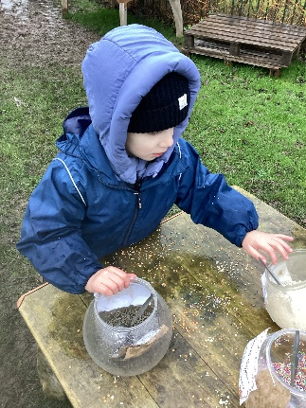
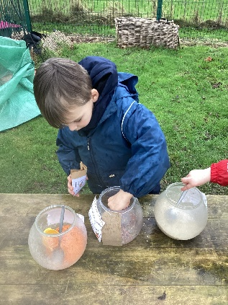
INDEPENDENT RESILIENT YEAR ONE


