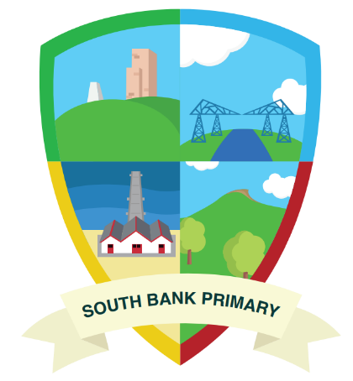
South Bank Primary School
Early Years Foundation Stage Curriculum

South Bank Primary is a fun, safe and creative school that makes hard work fun.
We laugh, learn and persevere.
We are given the wings to follow our dreams and be the best we can be.

South Bank Primary School Early Years Foundation Stage

Intent
At South Bank Primary School our Early Years Foundation Stage aims to provide children with a high standard of education which focuses on the importance of play and quality interactions. We understand that the experiences for a child between birth to five are paramount in order for a child to succeed socially, emotionally and academically. We pride ourselves on how well we know each child. As skilful practitioners we are able to capture children’s interests and move their learning on through a child led approach, fostering a love of learning and independence in a language-rich, inclusive environment.
Reading is integral to our curriculum in Early Years and we aim to instil a lifelong love of reading in our youngest children right from when they join us in Nursery. Our curriculum places books at the heart of learning and we carefully choose fiction, non-fiction and poetry to deepen knowledge, widen vocabulary and evoke responses in our early readers.
Our curriculum shows progression and has been carefully designed to ensure all children have the skills and knowledge to make a successful transition into KS1.
“Play builds the kind of free-and-easy, try-it-out, do-it-yourself character that our future needs.”
James L. Hymes, Jr.
Implementation

The curriculum provides a play-based and experiential learning environment, combined with focussed teaching and basic skills, to ensure children make rapid progress before moving onto Year 1. The children in both Nursery and Reception are provided with ample opportunities accessible in our indoor and outdoor provision. They engage in planned, focussed activities as well as self-initiated and free flow activities.

The children will learn new skills, acquire new knowledge and demonstrate understanding through the seven areas of the EYFS curriculum. These areas are split into three prime areas and four specific areas. The three prime areas are those which the children should develop first and are considered most essential for the healthy development and future learning of our children.
• Personal, Social and Emotional Development
• Physical Development
• Communication and Language
• Literacy
• Mathematics
• Understanding the World
• Expressive Arts and Design
We plan in the moment in order to seize teachable moments. This means we are constantly listening and looking out for occasions when a child shows an interest, so that we can build upon that spark ignite that curiosity, deepen their knowledge and extend their learning. Alongside planning in the moment throughout the year we have pre planned specific themes which will guide the children in their learning journey and ensure full coverage of the curriculum.
Play is the building block of a child’s intellectual, social, emotional, physical and language skills. A large portion of a child’s day at South Bank Primary is spent accessing the learning environment which is full of rich and open-ended learning resources and opportunities. We also encourage our children’s contact with the natural world and their environment. Being outside allows them to be animated, excited, physical and noisy! Forest School is delivered by a fully trained member of our team who plans and delivers a learning a programme that focuses on holistic development and growth in children. During their time at Forest School, with support from our Forest School leader children build on problem-solving skills, confidence, independence and resilience as they are allowed to test their limits in the natural world.
We recognise the importance of providing a meaningful language rich environment; we want our children to be able to express themselves and engage in conversations with their friends and adults. We share stories and sings songs regularly throughout the day which have been carefully chosen in order to meet the specific developmental needs of each child from our two-year-old provision through to Reception. This supports language development, increased vocabulary and thinking skills.

Welcomm is a toolkit we use in order to assess children’s language skills, if intervention is needed highly skilled practitioners carry out fun, play based activities in order to move children forward.
In the Summer term of Nursery, children will begin to access Read, Write, Inc, a systematic phonics approach which runs from Nursery age up to Year 6.

Mathematics is taught through daily discrete small group sessions. A long-term plan has been designed for Nursery children to learn the basic mathematical concepts. Reception children are taught through Power of Maths, a scheme used across school. Power of Maths is aligned to the NCETM Mastering number progressions and schemes of learning. Children are able to apply their new learning and skills through our resource rich, purposeful environment whereby they can explore independently or with support from practitioners.
Children are formally assessed at different checkpoints throughout Nursery and Reception in order to measure progress and ensure they are on track to achieve the ELG at the end of the Reception year. Floor books, learning journey displays, dialogue between staff and parents are all used in order to record children’s learning and progress across the year. Photographs are used to celebrate children’s learning and achievements.

Impact
At South Bank Primary School, we aim to ensure that all children across the EYFS achieve their full potential by providing a broad and balanced curriculum. Our creative and balanced provision of learning experiences enables our children to develop as happy, motivated, and independent learners. We strive to ensure each child makes excellent progress from their starting points in Nursery all the way through to the Early Learning Goals at the end of Reception. All children get the best possible start to their school life and develop the knowledge and skills needed to succeed as they continue their learning journey into Key Stage One.
At the end of EYFS our children;
- have strong communication skills, both written and verbal. Our children also listen respectfully and with tolerance to the views of others,
- children have been exposed to a wide of range books and have a developed a love of reading and the skills needed in order to retell stories,
- take pride in all that they do, always striving to do their best,
- demonstrate emotional resilience and the ability to persevere when they encounter challenge,
- develop a sense of self-awareness and become confident in their own abilities,
- are kind, respectful and honest, demonstrate inclusive attitudes and have a sense of their role in our wider society
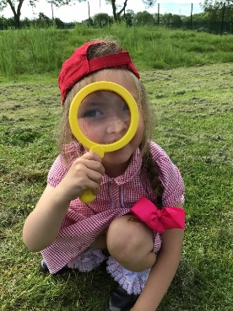
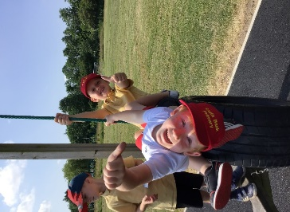
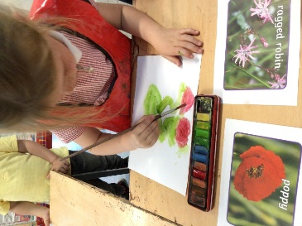
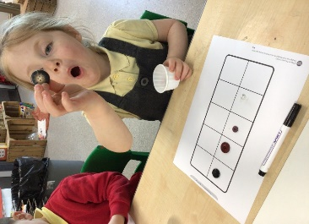

Communication and Language

On entry to 2 year olds | On entry to 3 year olds | Mid-nursery checkpoint | On entry to Reception | Mid-reception checkpoint
- Is able to use key vocabulary relating to everyday objects and needs.  - Identify familiar objects and belongings e.g. ‘James’ car’, ‘red apple.’  - Answer ‘where’ questions using gestures e.g. ‘where is the ball?’ Child points to ball.  - Understand and follow short commands e.g. ‘find your coat’ ‘put teddy away, ‘jump on the spot.’  - Make themselves understood and can become frustrated when they cannot  - Can understand simple questions with the use of visual cues. | - Can speak in short sentences which can be understood by others, e.g. ‘I need the toilet.’  - Beginning to use vocabulary from every day experiences.  - Understand and follow longer instructions e.g. ‘put the books in the box’, ‘put the pens in the pot.’  - Answer ‘who’ and ‘what’ questions relating to pictures or actions.  - Can sit for group time for a short period of time (5 minutes) e.g. greeting song, nursery rhyme, short picture book. | - Can take turns in a simple conversation with adults and peers about a topic of interest.  - Understand and use prepositional language such as, ‘under’, ‘on top’, ‘next to’, ‘behind.’  - Beginning to listen and concentrate for an extended period of time, not easily distracted e.g. a longer story, circle time.  - Take an active part in group time discussions, making comments and showing and interest and links to other children.  - Answer ‘how’ and ‘why.’  - Understand a question or instruction that has two parts e.g. ‘Put your coat on and line up.’  - Use a wide range pf vocabulary from their every day experiences. | - Articulate their ideas and thoughts in well-formed sentences.  - Use connectives to extend sentences / thoughts and ideas e.g. “I like to go to the park and eat ice cream.  - Talk about experiences and events in detail e.g. a birthday party.  - Listens and concentrates during group time sessions.  - Answer ‘who,’ ‘what,’ ‘why,’ ‘when,’ ‘how,’ questions with increasing detail.  - Uses new vocabulary in different contexts. | - Asks questions to find out more and to check they understand what has been said to them.  - Initiates a back and forth conversation with peers and teachers.  - Learns and uses new vocabulary quickly.  - Begin to use full sentences to express their ideas and feelings  - Begin to use a range of tenses correctly – with some support/ modelling from adults  - Answer in detail questions relating to ‘who,’ ‘what,’ ‘why,’ ‘when,’ ‘how’ using new vocabulary.

On entry to 2 year olds | On entry to 3 year olds | Mid-nursery checkpoint | On entry to Reception | Mid-reception checkpoint  Personal, Social and Emotional Development
•Finds ways to calm themselves through being calmed and comforted by their key person.  •Engage with others through gestures, gaze and talk.  •Beginning to respond to simple boundaries, for example, stop, wait.  •Can play with increasing confidence on their own or play parallel to another child or adult.  •Joins in with basic hygiene routines, for example, washing hands and shows an interest in dressing themselves. | •Beginning to express a wide range of emotions.  •Shows understanding and cooperates with some boundaries and routines.  •Interested in others play and beginning to join in.  •Usually dry and clean during the day.  •Beginning to help with own clothing and hygiene routines. | •Identify feelings, such as, worried, sad, angry, happy.  •Play with one or more other children extending and elaborating play ideas.  •Knows how to act in a specific situation.  •Shows more confidence in new social situations.  •Selects and uses activities with help when needed.  •Independently accesses the toilet.  • Can dress themselves with minimal support. | • Can talk about their feelings.  - Can talk about how others might be feeling and knows that some actions and words can hurt others feelings.  •Demonstrates friendly behaviour.  •Can adapt behaviour to different events, social situations and changes in routine.  •Follows simple instructions to reinforce behavioural expectations.  • Beginning to manage own risks when playing. | •Takes steps to resolve conflicts and begin to find a compromise, sometimes with support.  •Develops special friendships with other children and offers empathy and comfort when necessary.  •Confident to speak to others about own needs, wants, interests and opinions.  •Aware of behavioural expectations and understands the need for consequences.  •Understands their own and other people’s feelings.  •Shows an understanding of what can contribute to a healthy lifestyle. For example, exercise, eating, sleeping and hygiene.

Physical Development

On entry to 2 year olds | On entry to 3 year olds | Mid-nursery checkpoint | On entry to Reception | Mid-reception checkpoint
- Picks up objects with palmer grip with growing confidence.  - Walks steadily unaided  - Avoids obstacles  - Uses cutlery independently to feed themselves e.g. putting cutlery to mouth to feed themselves.  - Roll a ball  - Clap and stamp to music  - Sit on a push along wheeled toy | - Use pincer grip to pick up a range of objects.  - Shows control and confidence during fine motor experiences such as blocks for building and malleable materials.  - Can run steadily with a growing awareness of the space around them.  - Shows good control when using cups for drinking and cutlery for eating, avoiding spillages.  - Take an active part during changing routines e.g. arms in sleeves, legs in trousers, feet in socks.  - Rolls a ball, kicks a ball, beginning to show awareness of how to catch a large ball.  - Sit on a wheeled toy and propel using their feet | - Move in a range of ways: jumping, skipping, crawling, sliding etc.  - Demonstrates special awareness when moving in a range of ways.  - Begin to show increased control when balancing.  - Beginning to understand the importance of risk taking.  - Beginning to understand what contributes to a healthy lifestyle e.g. exercise, sleep and food.  - Has an awareness of oral hygiene and routines on how to keep teeth healthy  - Makes snips in paper with scissors  - Begin to put own coat on  - Catch a large ball and kick a ball at a target  - Demonstrate good control when riding a wheeled toy. | - Has a good sense of special awareness and can avoid large and small obstacles.  - Puts on own coat and zips up with adult support.  - Demonstrates good control when balancing.  - Manage own risks  - Understands and talks about what contributes to a healthy lifestyle.  - Understands the importance of oral hygiene.  - Has an awareness of the movement needed for using scissors.  - Participate in throwing and catching games, showing increased control.  - Sit on a balance bike and begin to move their feet | - Beginning to have an awareness of others when moving around in a variety of ways.  - Participates in throwing and catching games with accuracy.  - Can talk about risk and identify and manage own risk and others when building and balancing.  - Can balance safely using skills learnt such as arms out, one foot in front of the other, walking and looking.  - Can use scissors correctly to cut a straight line.  - Can dress themselves independently and can zip up own coat.  - Uses vocabulary associated with oral health e.g. tooth decay.  - To confidently ride a balance bike

On entry to 2 year olds | On entry to 3 year olds  Early Reading | Mid-nursery checkpoint | On entry to Reception | Mid-reception checkpoint
- Enjoys songs and rhymes, tuning in and paying attention  - Enjoy sharing books with an adult  - Copy finger movements and other gestures linked to stories, songs and rhymes. | - Say some of the words in songs and rhymes  - Have favourite books and seek them out to share with an adult, another child or to look at alone  - Ask simple questions relating to a book of interest  - Listens to short stories one to one or in small groups | - Sing songs and say rhymes independently, for example, singing whilst playing  - Repeats words and phrases from familiar stories  - Develop phonological awareness through songs, rhymes, clapping and initial sounds  - Talk about stories they have read | - Orally blend CVC words  - Show awareness of alliteration  - Hear and say the initial sounds in words  - Use pictures to make up a simple story  - Listens to stories with increased attention and recall  - Can identify and say the sounds of some of the letters in their name. | - Read and say the sounds in the alphabet – in any order  - Blend sounds into words  - Read a variety of red/nonsense words from RWI programme  - Begin to read a simple phrase  - Uses vocabulary and forms of speech that are increasingly influenced by their experiences of reading  - Describe story settings, order of events and characters in a story  - Bring a story to life  - Listen attentively to stories consistently and answer questions appropriately about the story

On entry to 2 year olds | On entry to 3 year olds  Early Writing | Mid-nursery checkpoint | On entry to Reception | Mid-reception checkpoint
- Enjoys a sensory experience of making marks within a variety of forms, for example, foam, water, sand, mud, paint  - Picks up objects with palmer grip with growing confidence | - Uses pincer grip to pick up a range of objects  - Shows control and confidence during fine motor experiences  - Enjoys mark making in a range of ways, for example, drawing on paper, using chalks | - Sometimes gives meaning to their drawings and paintings  - Understands that writing carries meaning  - Creates lines and circles, from shoulder to elbow  - Begin to use a tripod grip when holding mark making tools specific to writing e.g. a pencil for writing | - Attempts to write own name  - Imitates adults writing by using continuous lines of shapes and symbols from left to right  - Beginning to write/ draw for a purpose e.g. a card for Mummy, a picture of Daddy.  - Use a tripod grip effectively when mark making  - Begin to take an interest in copying and forming letters. | - Hold pencil effectively to form recognisable letters, mostly formed correctly  - Use phonic knowledge to write simple words and phrases  - Begin to write a range of red words correctly  - Identify key features of a sentence, for example, capital letters, finger spaces and full stops.

On entry to 2 year olds | On entry to 3 year olds  Early Mathematics | Mid-nursery checkpoint | On entry to Reception | Mid-reception checkpoint
- Complete inset puzzles  - Listen to and enjoy counting rhymes and songs  - Stack objects using flat surfaces  - Looks for things that have been moved out of sight  - Begin to understand language of size, for example, big and small | - Beginning to use number language in play  - Counting in everyday contexts, sometimes skipping numbers, for example, 1,2,3, 5  - Group objects, for example, by colour, size  - Show an interest in shape and space by playing with shapes or making arrangements with objects | - Accurately uses some number names and number language in play  - Can accurately count up to 5 objects  - Shows awareness and understanding of mathematical language (including times of the day), for example, lots, more, less, bigger, smaller, later, next  - Shows interest in shapes during play, for example, using construction  - Identify simple 2D shapes, for example, circle square, triangle, rectangle  - Sing a range of counting songs representing numbers using fingers, pictures or objects  - Subitise to 1 using pictures, spots on a dice etc.  - Begin to show an awareness of patterns e.g. ABAB | - Enjoys reciting numbers from 0-10  - Counts up to 5 objects from a larger group  - Recognises some numerals of personal significance  - Understand the concept of adding and takeaway through practical activities, songs and rhymes  - Begin to talk about the shapes of every day objects  - Uses shapes appropriately for tasks  - Subitise numbers 1 and 2.  - Can complete a simple repeated pattern e.g. red, back, red, black. | - Count to 20 verbally  - Count up to 10 objects reliably  - •Identify one more and one less than a given number up to 10  - Begin to compare quantities of objects, for example, say when a group has more, less, same  - Begin to identify odd and even numbers  - Finds the total number of items in two groups by counting all of them  - Recognise and order numbers to 10  - Can subitise numbers to 5 by identifying familiar patterns, for example, spots on a dice  - Use some correct names for 3D solid shapes and 2D flat shapes  - Can recognise and complete a complex pattern e.g. red, black, yellow, red, black, yellow

On entry to 2 year olds | On entry to 3 year olds | Mid-nursery checkpoint | On entry to Reception  Understanding The World | Mid-reception checkpoint
SENSORY EXPERIENCES | SENSORY EXPERIENCES | - Use senses to explore  - Talk about themselves and their peers – make comparisons  - Talk about their home and who they live with  - Explore plants and living things within their immediate setting | - Talk about themselves and their family  - Be interested in various occupations  - Talk about where they live  - Develop positive attitudes to different people and that there are other beliefs in society  - Begin to understand there are other countries in the world  - Explore themes of growth, life cycle and care for the environment and living things  - Talk about what they see using a wide vocabulary  - Explore how things work | - Share family stories  - Talk about the local community and name and describe familiar people  - Draw maps and trails around the environment  - Talk about people from the past  - Talk about and describe people who work in the local community  - Develop an understanding of different cultures  - Talk about how we care for the natural world  - Explore the seasons  - Observe and discuss animals and insects  - Experiment with forces, for example, through use of magnets

On entry to 2 year olds | On entry to 3 year olds  Expressive Arts & Design | Mid-nursery checkpoint | On entry to Reception | Mid-reception checkpoint
- Move and dance to music  - Anticipate phrases and actions in rhymes and songs, like ‘Peepo.’ | - Joins in with songs and rhymes. | •Remember and sing entire songs.  •Explore available materials and begin to work creatively | •Explore and engage in music and dance, performing solo or in groups.  •Select materials for a purpose  •Explores colour mixing  •Uses drawing to represent a range of ideas | •Sing a solo, matching the pitch and following the melody of a song.  •Can mix colours for a purpose  •Can join using different techniques, for example, split pins, glue, Sellotape  •Begin to plan and design a project

