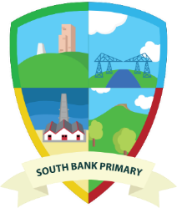

Personal Development Curriculum Overview
Daily |  | Meet and Greet  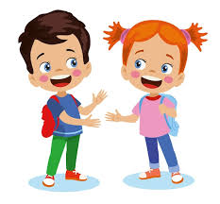  All pupils receive a warm and friendly welcome at the school doors. They have a ‘soft start’ to the day which allows staff to assess wellbeing and provide early intervention when necessary. |  |  | Breakfast and Lunch    Every pupil has the opportunity for breakfast and lunch including a wide range of different foods. This ensures the pupils have their basic needs met and they are ready for learning. Staff model appropriate etiquette skills and engage in low stake conversations with pupils. |  |  | Academic Support  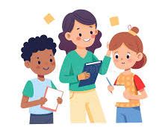  Live marking and positive use of support staff enables us to intervene quickly and support academic needs. Adaptations within the curriculum support individual needs. |  |  | Social and Emotional Support  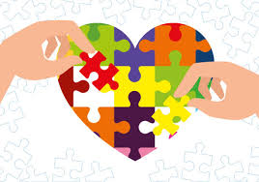  Staff, including our SEMHW Team are proactive when supporting children with social and emotional needs. They provide support to individuals using a range of techniques including sensory programs, indoor calming cubbie, sound and light room and activall.
Weekly | PSHRSE Lessons  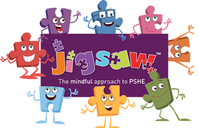 | Being Me in My World  Pupils understand their individual identity and their place within their immediate class, school, and the wider world. It emphasises a sense of belonging and a collaborative environment.  - Self-image  - Personal responsibility  - Aspirations | Celebrating Difference  Pupils are taught about diversity, respect and inclusion, helping to create a safer, more accepting community.  - Similarities and differences  - Challenging stereotypes  - Discrimination |  |  | Dreams & Goals  Pupils are supported in setting goals, exploring future options and developing resilience to achieve them.  - Hopes and dreams  - Career pathways  - Financial education  - Teamwork & resilience |  | Healthy Me  Pupils look at mental and physical well-being, encouraging informed, positive lifestyle choices.  - Coping strategies  - First aid  - Substance misuse (age appropriate)  - Nutrition |  | Relationships  Pupils look at various types of relationships and the skills needed to maintain healthy interactions with one another.  - Communication skills  - Conflict resolution  - Friendships  - Loss and bereavement |  |  | Changing Me  Pupils are taught about personal changes and transitions throughout life, including physical, emotional and social changes.  - Puberty  - Transitions  - Safeguarding
Weekly | SMART Curriculum  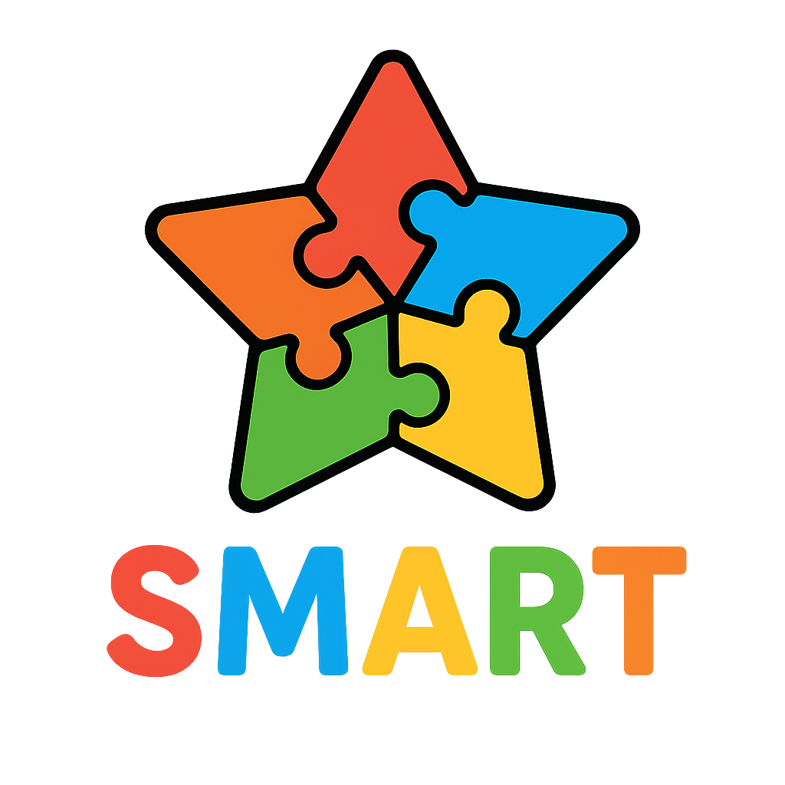 | Social Skills  Teaching pupils to develop communication focussed social skills is essential because communication and language form the foundation for all areas of learning and development. |  | Mental Health Management  Mental Health Management builds essential life skills like emotional regulation and resilience, which positively impact pupils social and academic success and improves long-term wellbeing. This early education helps pupils manage challenges, build positive relationships, and creates a foundation for future health and employment. |  |  | Aspirations  Teaching pupils about aspirations drive future achievement, builds self-awareness, and provides a sense of purpose and motivation. It encourages pupils to explore their potential and can lead to higher motivation and better educational outcomes. |  | Resilience  Teaching pupils’ resilience is vital for children’s personal development because it equips them with the ability to cope with setbacks, leading to improved mental health, better problem-solving skills and enhance self-confidence. |  |  | Teamwork  Teamwork skills develop crucial life skills like communication, cooperation, and conflict resolution, while also boosting pupils self-confidence, social awareness, and empathy. Pupils learn to appreciate diverse perspectives, build strong relationships, which prepares them for future success in the workplace and community.
Weekly | Assemblies   | School Values Linked |  |  | Sing Education – Singing Assembly |  |  | Picture News Assembly |  |  | Celebration Assembly
Weekly | Favourite Five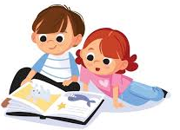 | Timetabled across each week are our ‘Favourite Five’ reading sessions. Every half term we reveal an exciting set of ‘Favourite Five’ books into each classroom. These books are chosen from a range of texts ensuring that the pupils are exposed to diverse characters, cultures, genres and a range of authors. The idea behind this is that these books are re-read to the pupils frequently so that they can learn the story, read them to each other and practise using their storyteller voices. They will know these stories by heart and will be able to pick up the books and be immersed. These books support the pupil’s personal development. These include, but are not limited to:  - Loyalty  - Power  - Fame  - Diversity  - Persecution  - Social class  - Empathy  - Homelessness  - Culture  - Individual Liberty  - Democracy  - Rule of Law  - Tolerance  - Respect  - Conflict
Weekly | Enrichment   | Pupils participate in a range of enrichment opportunities, enhancing their development of core skills essential for life. By participating in activities which encourage their communication skills and build robust problem solving skills. Many of the opportunities provided foster critical thinking, where pupil’s learn to analyse situations and make informed decsions. They gain valuable organisation skills by mangaing tasks and projects. These include, but are not limited to:  - Forest Schools  - After – school clubs  - Animex Academy  - Richard Shepard foundation of Music  - MFC partnership  - Sports Week
Half-Termly | Personal Development Pathway  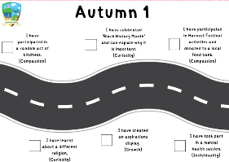 | Every year group has a Personal Development pathway which makes clear links to our school values. The Personal Development pathway helps bridge the gap in knowledge and experiences for all pupils, which promotes social mobility and equality. It ensures pupils have opportunities to develop essential knowledge, skills and behaviours needed for future success, like visiting museums, engaging with different cultures and building confidence in social situations.
Half-Termly | Subject Careers Focus   | Every half term, pupils complete a reading comprehension activity linked to a career within a subject area. This supports pupils to understand the value of the subjects they learn and raises their aspirations by widening their knowledge of potential careers within the wider community. The careers covered are all based within the local area and use SPARK to support using videos. Pupils across school participate in Teesside Charities whereby employers from around the area visit school to deliver a workshop around their job. Pupils in Year 4 participate in Building Our Futures. Building Our Futures is an exciting programme bringing careers education to life in every primary school across Redcar and Cleveland. By sparking curiosity, building confidence, and raising aspirations, pupils are able to see the possibilities their future holds.
Intertwined | British Values   | A key strength of our provision is the way in which staff and children demonstrate a secure understanding of the five British Values, confidently making links to curriculum areas and recognising how these values extend beyond the classroom into everyday life. We have made links across the 5 British Values in each curriculum area and evidence this throughout our planning, classroom displays and Canva.
Intertwined | Rights Respecting  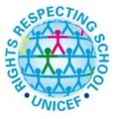 | Since 2019, we have been working towards our accreditation of being a Rights Respecting School. We were accredited Gold Award in June 2025. Being a Gold Rights Respecting School links to personal development by embedding children's rights into school life, which enhances pupils' self-esteem, confidence, resilience, and overall wellbeing. This approach fosters a more positive school culture by improving relationships, reducing bullying, and encouraging active and responsible citizenship with a strong moral compass.
Intertwined | IQM Award  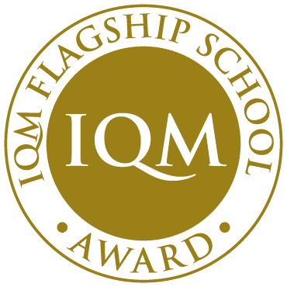 | In April 2025, we were awarded IQM Flagship award. This is through successfully maintaining their Centre of Excellence status for over 3 years. We have inclusive practice threaded throughout all we do. Flagship schools are sector leaders in inclusion, innovative practice, and contribute to educational research. By achieving the IQM Award, we demonstrate our commitment to embedding inclusive practice at the heart of everything we do. Our school gives all pupils regardless of their age, gender, ethnicity, achievements or background the equal opportunities to succeed.
Intertwined | Pupil Leadership  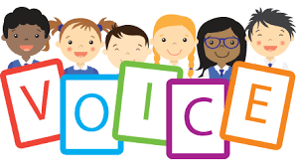 | Having pupil leadership is important to us because it builds essential skills like confidence, communication, and teamwork while preparing pupils for future success. These roles give pupils a voice in their school, teach them responsibility and problem-solving, and help create a positive and inclusive school community. The children complete an application for each role and are voted into position by their peers. The pupil leadership positions we have in school are:  - Sports Leader  - Rights Respecting Council  - Well-being Ambassador
Intertwined | Mental Health Team  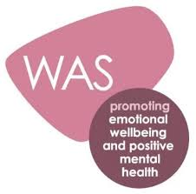 | At South Bank Primary our pupils are the focus and at the heart of all we do. Whilst education and learning is the priority of every school, we recognise that if pupils are struggling with their social, emotional, mental health and wellbeing then they will not meet their learning potential or be the best they can be. We encourage our children to express themselves in different ways through talking, creative work and play. Our SEMHW team use an integrative therapeutic approach, which is backed by research, brings together different strands of therapeutic thinking to support the development of each pupil. We are proud to share that we have been successful in achieving the Wellbeing Award for Schools 2022 to 2025.
Extras | Interventions  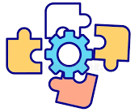 | All elements of the school curriculum are highly adaptive to the needs of the pupil’s within the setting and how to support them to be successful, well-rounded individuals in the community. Where identified by the school, parents/carers, external agencies or the pupils themselves, we will support pupils in providing and referring to bespoke interventions. Some interventions include, but are not limited to:  - Cause Foundation  - Occupational Therapy  - STARS  - Knife Crime  - Fire Safety / Prevent  - Wellcomm  - Daisy Chain  - Open Well (Food Bank)  - Eat Well (Public Health)  - EVA  - Daisy Chain  - Speech & Language  - MIND  - Junction  - Harbour
Extras | Trips, Visits and Residentials   | We recognise that many of our pupils may not have opportunities to develop their cultural capital in comparison to their peers. It is for this reason; trips and visits form an integral part of our curriculum. The majority of these are evidence throughout Personal Development Road Maps and include, but are not limited to:  - Adventure Week  - Newby Whisk  - Life Museum

