South Bank Primary School
Head Teacher: Miss Tammy Cooper
office@southbankprimary.co.uk
01642 453451
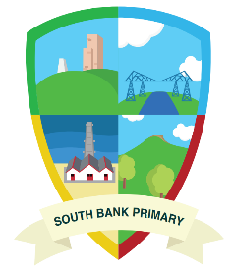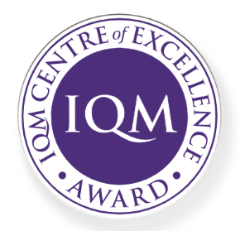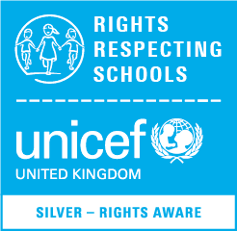

Relationships Education (RE)
At South Bank Primary School, the teaching of Relationships Education follows the DfE statutory guidance. It consists of high-quality, age-related and developmentally appropriate content, which is taught sensitively and inclusively, in an environment, which champions respect for all.
We are committed to ensuring equality of opportunity for all pupils, staff, parents and carers irrespective of race, gender, disability, belief, sexual orientation, age or socio-economic background. We are resolute in developing a culture of inclusion and diversity in which all those connected to our school feel proud of their identity and ability to participate fully in school life.
Relationships Education is delivered through a detailed Personal Social Heath and Economic Education programme of study with a mindful approach. Through this scheme of work (Jigsaw), children learn about:
- Families of People Caring for Us: The characteristics of a healthy family and how relationships work.
- Caring friendships: The importance of friendships and what is considered a healthy and happy one.
- Respectful Relationships: Respect towards others and oneself.
- Online Relationships: The importance of discriminating between the real and online world.
- Being Safe: How the children can keep themselves safe.
During their time in school, children develop an understanding of different types of families in school and the wider world, different groups in society and different types of relationships. Through the teaching of Jigsaw, our children foster respect for differences and understand that all respectful relationships are characterised by love and care.
Jigsaw follows the statutory requirements and ensures that the teaching of Lesbian, Gay, Bisexual and Transgender (LGBT) content is fully integrated into the programme of study and is delivered so that children develop age- appropriate knowledge and understanding during their time at primary school.

Fostering respect for different types of relationships is part of the teaching of Relationships Education. It is essential that children are educated about healthy relationships, regardless of the form or type, enabling them to grow up with inclusive and accepting attitudes preparing them for life in modern Britain and the world. LGBT content will arise in the teaching of different types of families and as a primary school, we are encouraged and enabled to cover this content at a timely point as part of the curriculum. All coverage of LGBT will be delivered in a relaxed atmosphere and in a way that is sensitive and respectful of all.
The teaching of Relationships Education and LGBT ensures that children understand:
- That families, either within school or within the wider world, may look different from their own family; they should respect those differences and know that other children’s families are also characterised by love and care.
- That stable, caring relationships, which may be of different types, are at the heart of happy families.
Relationships Education is at the heart of everything we do at Newcomen.
All aspects of this subject will support children along their exciting journey to becoming happy, successful members of society.

The Relationships Education Policy is available to view on the website.

Warmest regards,
Tammy Cooper
Miss Cooper
Head Teacher
South Bank Primary School

