Our Poetry Early Years
South Bank Primary School
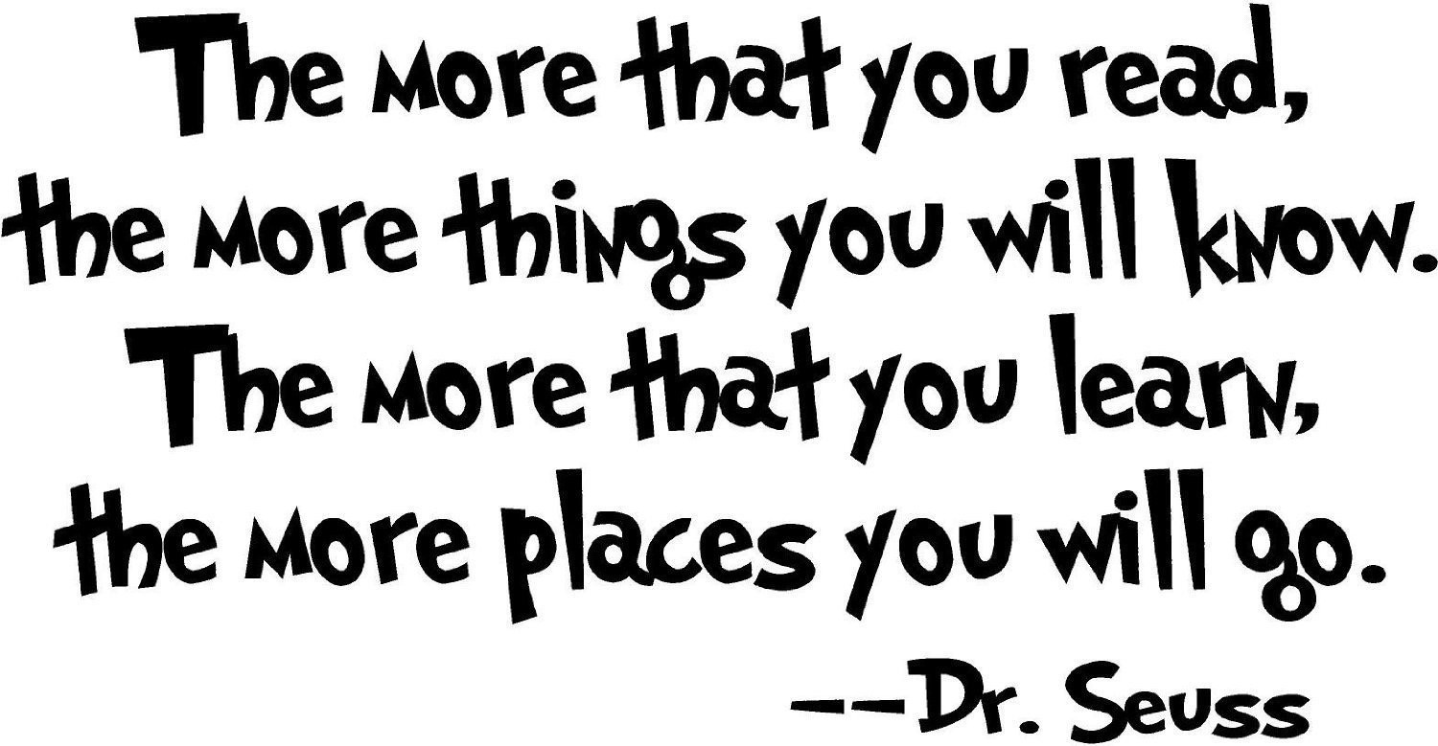

- Twinkle Twinkle
- Incy Wincy Spider
- Ba Baa Black Sheep
- Humpty Dumpty
- Row Row Row your Boat
- Hickory Dickory Dock
- Miss Polly had a Dolly
- I’m a little Teapot
- Wind the bobbin up
- Grand Old Duke of York
- Sailor went to sea
- Jack and Jill
- Doctor Foster
- Polly put the kettle on
- Old Mother Hubbard
Seasonal/topic links:
I’m a Little Hedgehog What the Robin Told Autumn poem
Little Red Hen

Poems from the following books:
Commotion in the Ocean Mad about Minibeasts Rumble in the Jungle

