Pre and post assessment
POST

PRE

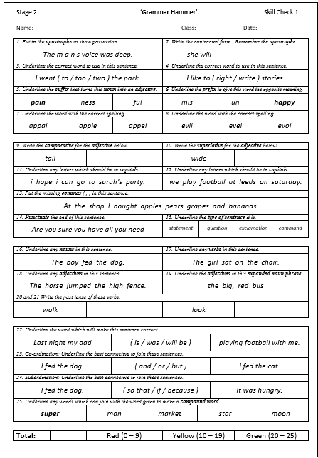
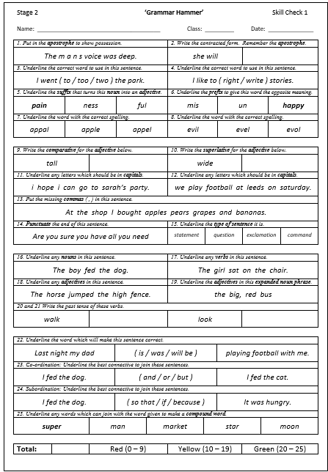

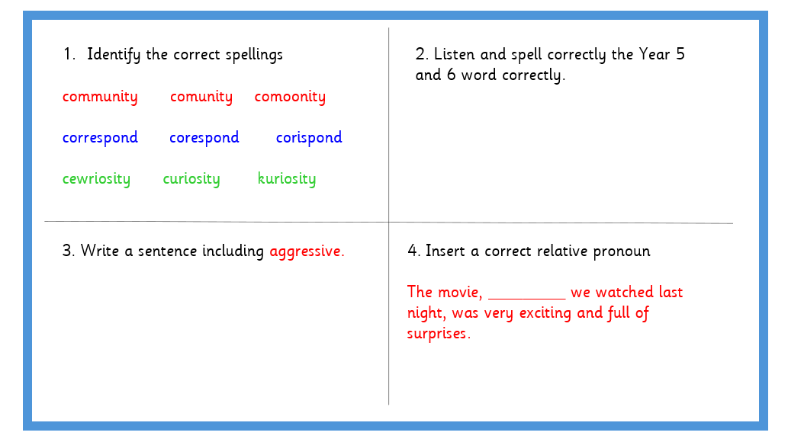
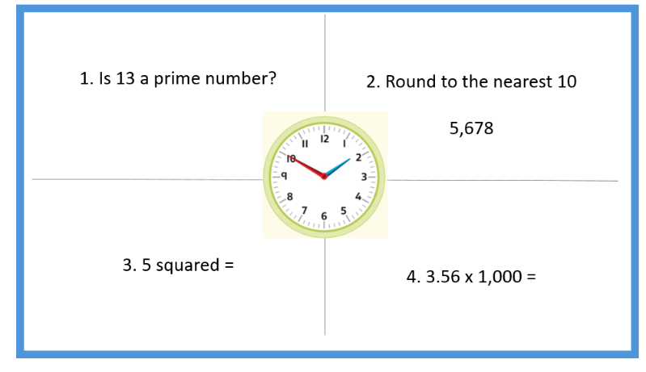
Retrieval practice

Highlight in blue to evidence retrieval practice e.g in history, children have been learning about Crime and Punishment and are given a retrieval task following on from this learning and this is indicated by a blue highlight in the margin as shown below.

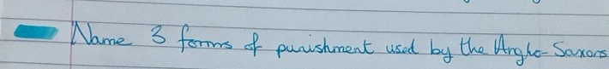

Identification of intervention needed

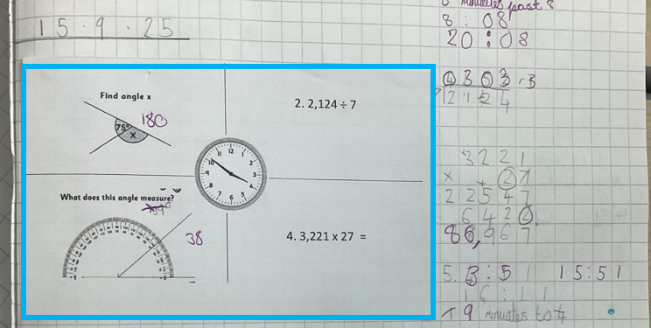

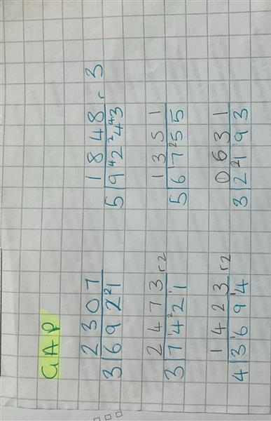

Intervention delivered.

Modelled/scaffolded in blue pen.

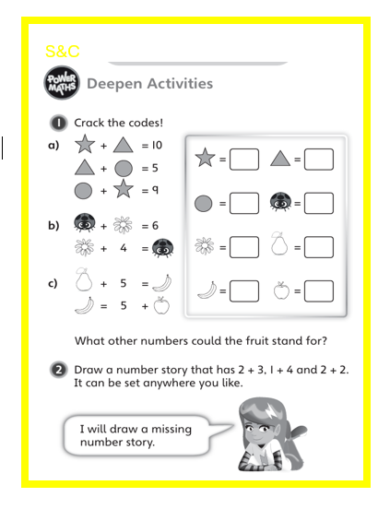
Stretch and challenge

Stretch and challenge is identified with a yellow box or highlighter and with code S&C.
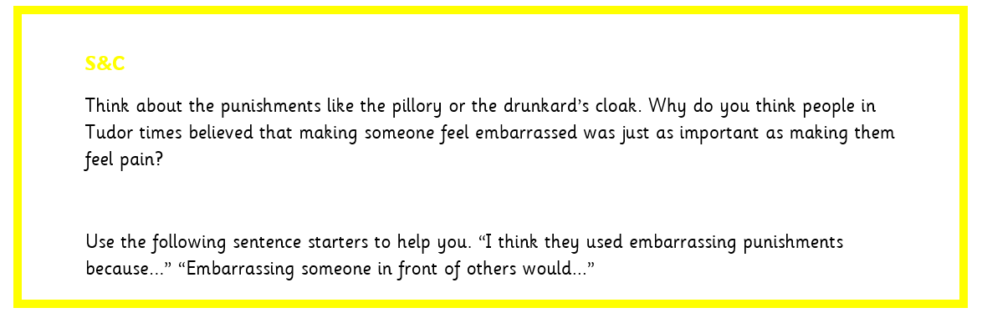

Teacher marking
Graduated response based on the needs of the child. Example below showing differentiation in use of identifying error/mistake in child’s work and how they respond.
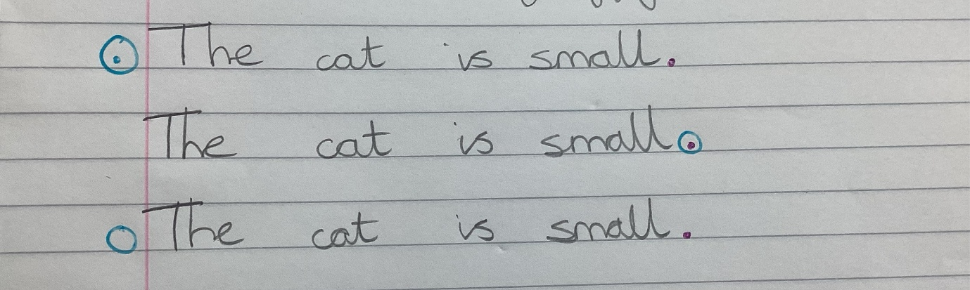
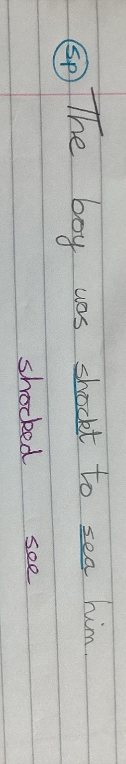

Spelling errors identified using code sp and responded to by child in purple pen.

