Early Years Foundation Stage (EYFS) Policy 2026
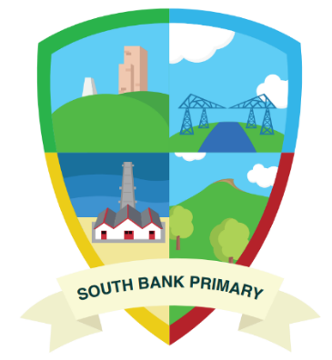
South Bank Primary School

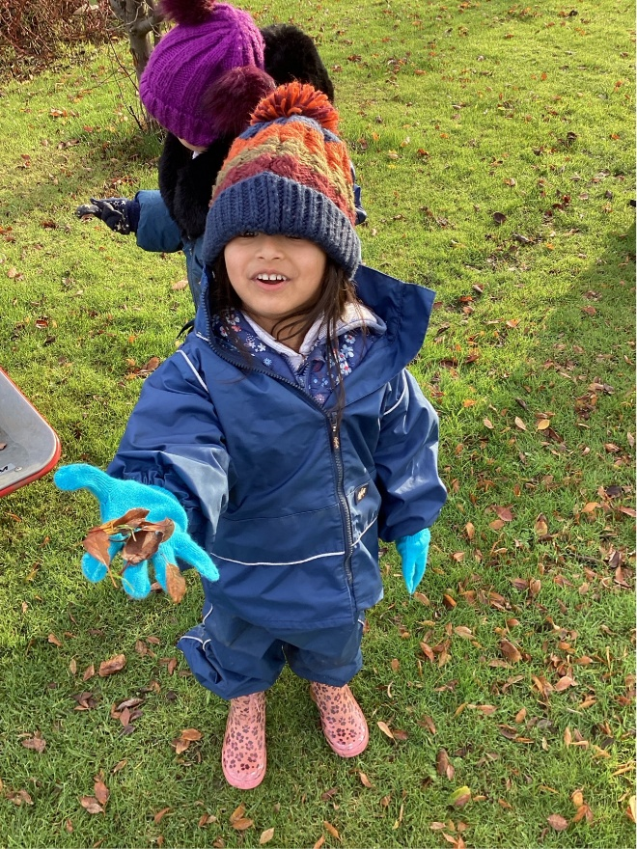
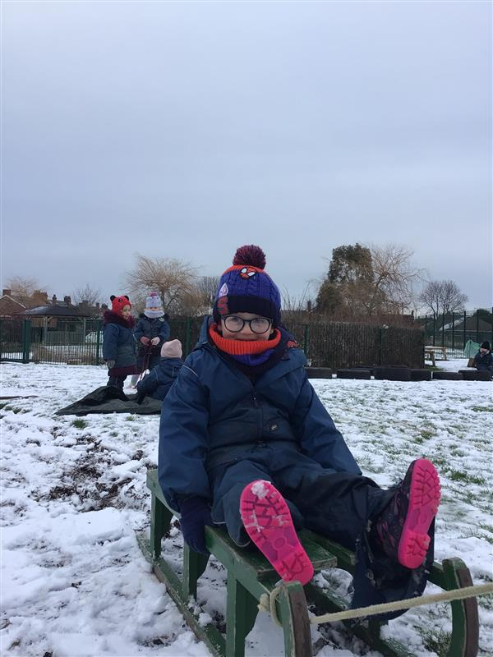

Contents
1. Introduction 3
2. Aims 4
3. Legisilation 4
4. Enabling Environement 4
5.Curriculum 5
6. Assessment 7
7. Working with parents 6
8. Safeguarding………………………………………………………………………………………………………………………………….8

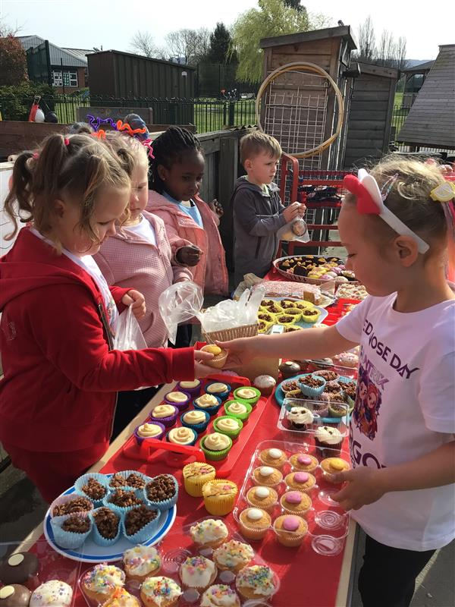
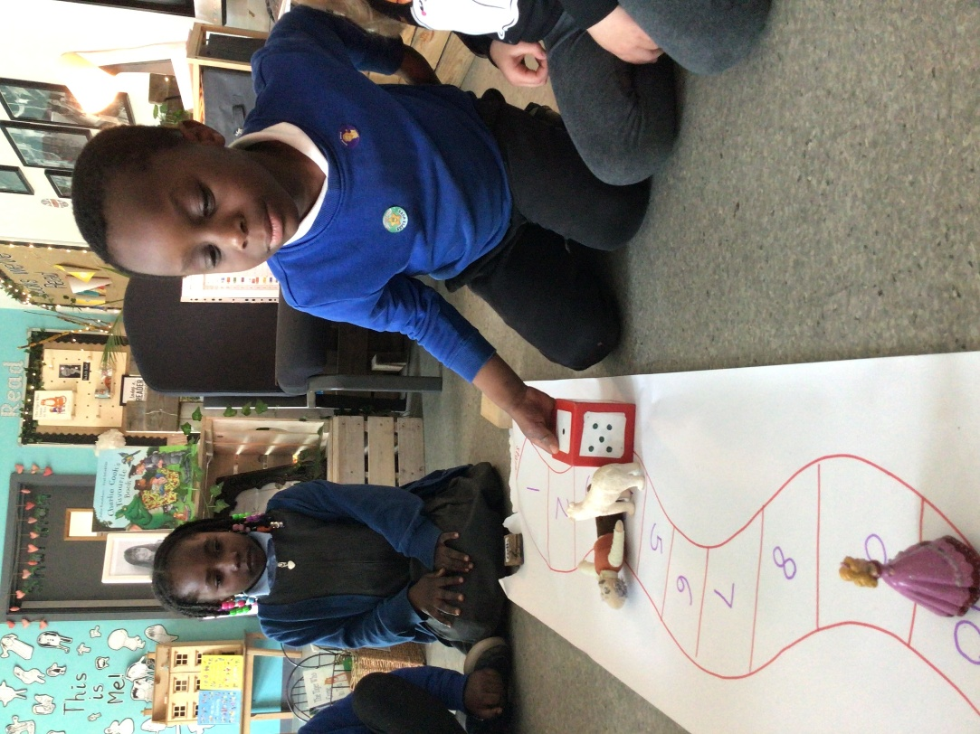

1. Introduction
“Every child deserves the best possible start in life and support to fulfil their potential. A child’s experience in the early years has a major impact on their future life chances. A secure, safe and happy childhood is important in its own right, and it provides the foundation for children to make the most of their abilities and talents as they grow up.”
(Statutory Framework for the Early Years Foundation Stage)
The Early Years Foundation Stage applies to children from birth to the end of the reception year. At South Bank Primary School children are able to start as young as 2. Early childhood is the foundation on which children build the rest of their lives. At South Bank Primary School we greatly value the importance that the EYFS plays in laying secure foundations for future learning and development. However, we also believe that early childhood is valid in itself as part of life. It is important to view the EYFS as preparation for life and not simply preparation for the next stage of education.
Throughout this policy, the Early Years Foundation Stage (EYFS) refers to children in our 2 Year Old setting, Nursery and Reception class.
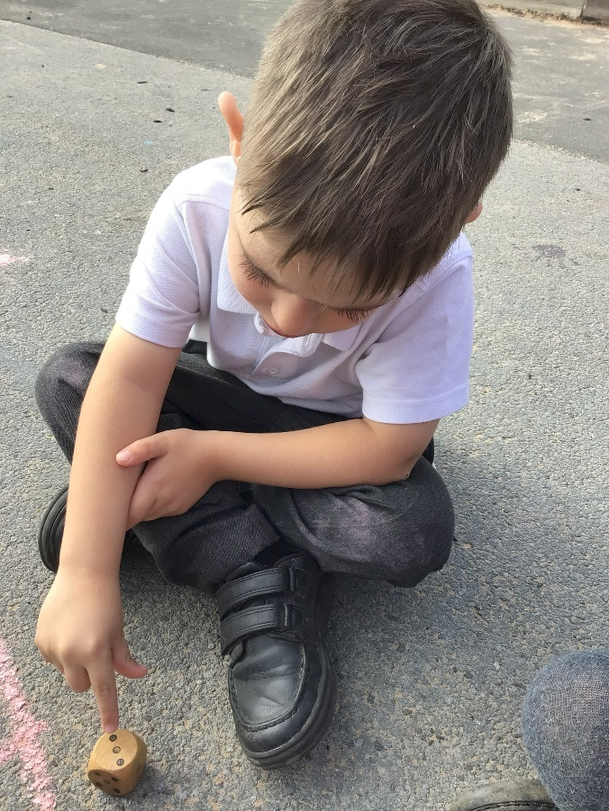
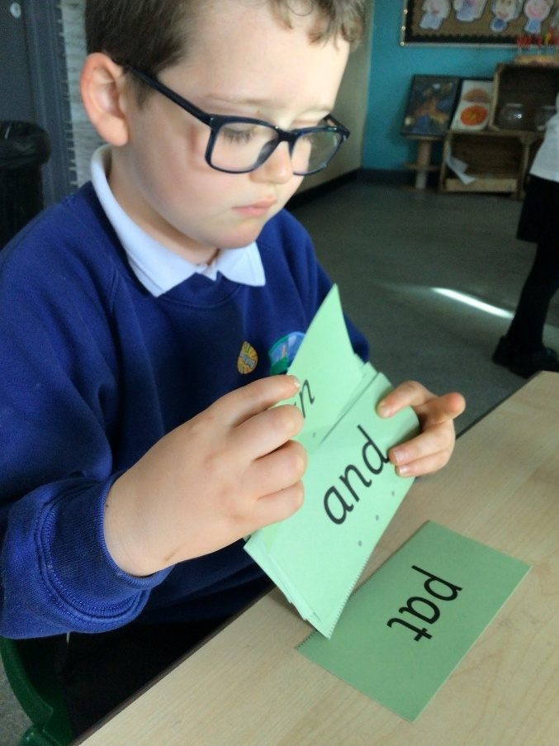
OFSTED 2021
Teaching should not be taken to imply a ‘top down’ or formal way of working. It is a broad term that covers the many different ways in which adults help young children learn. It includes their interactions with children during planned and child-initiated play and activities: communicating and modelling language, showing, explaining, demonstrating, exploring ideas, encouraging, questioning, recalling, providing a narrative for what they are doing, facilitating and setting challenges. It takes account of the equipment adults provide and the attention given to the physical environment, as well as the structure and routines of the day that establish expectations”
2. Aims
At South Bank Primary we will:
- Provide a happy, safe, stimulating and challenging programme of learning and development for the children to experience as they begin their journey through school.
- Children receive a broad and balanced curriculum that gives them the broad range of knowledge and skills needed for good progress through school and life
- Quality and consistency in teaching and learning so that every child makes good progress and no child gets left behind
- Develop excellent relationships with parents and carers to build a strong partnership in supporting their children. Every child is included and supported through equality of opportunity and anti-discriminatory practice
- Provide a caring and inclusive learning environment, which is sensitive to the requirements of the individual child including those who have additional needs.
The early-years education we offer our children is based on four guiding principles.
- Every child is a unique child, who is constantly learning and can be resilient, capable, confident and self-assured
- Children learn to be strong and independent through positive relationships
- Children learn and develop well in enabling environments with teaching and support from adults, who respond to their individual interests and needs and help them to build their learning over time. Children benefit from a strong partnership between practitioners and parents and/or carers.
- Importance of learning and development. Children develop and learn at different rates. The framework covers the education and care of all children in early years provision, including children with special educational needs and disabilities (SEND).
(Statutory framework for the early years foundation stage, 2025)
3. Legislation
Effective from 1 September 2025, the revised EYFS sets out strengthened safeguarding and welfare requirements for all early years providers, including stricter rules around recruitment (such as obtaining references), monitoring prolonged absences of children, safer eating practices, and ensuring children’s privacy during toileting and nappy-changing. Additionally, providers must integrate updated nutrition guidance, support whistle-blowing policies, ensure paediatric first-aid training for trainees/apprentices counted in staff: child ratios, and accommodate a new “Experience-Based Route” so that competent staff without full formal qualifications may be included in ratios at level 3.
4. Enabling Environment
The environment supports children to be fully engaged in purposeful play of their own choice and interest. As with the outdoor area, the indoor area allows for learning in all areas of development, but the two areas do not mirror each other. This is the ideal place for children to be calm and quiet (and we enforce this requirement firmly and consistently), pursuing activities which require small equipment and using resources that will not survive the outdoor elements. In the EYFS classes, the children choose where to go and what to do– they initiate their own learning and adults join them and support them in their pursuits. In order to support individual choice we have a workshop style environment setup in classes. In all areas, the resources are available and accessible to the children at all times, but nothing is set out. The areas are clear, stocked and tidy at the start of the day; the tables and carpet areas are free of equipment but the resources are available next to these areas.
This allows the children to be in control of their learning. They are able to select the area in which to play, the resources to use in that area and what to do with them. Obviously their choices are limited by the areas and resources available and it is therefore crucial to have appropriate areas with varied, high quality, open-ended resources. It is also vital that the areas are well stocked, tidy, clearly labelled (with picture and word) or shadowed and arranged to allow optimum access. We constantly review and reflect on the environment to see which areas are proving productive and which need altering.
5. Curriculum
Our curriculum for the Foundation Stage reflects the areas of learning identified in the Early Learning Goals. There are seven areas of learning and development that must shape educational provision in early years settings. All areas of learning and development are important and inter-connected. None of the areas of learning can be delivered in isolation from the others. Our children’s learning experiences enable them to develop competency and skill across a number of learning areas.
Three areas are particularly crucial for igniting children’s curiosity and enthusiasm for learning, and for building their capacity to learn, form relationships and thrive.
The three Prime areas are:
• Personal, Social and Emotional Development
• Communication and Language
• Physical Development
Staff will also support children in four specific areas, through which the three prime areas are strengthened and applied.
Specific Areas:
• Literacy
• Mathematics
• Understanding the world
• Expressive arts and design

Physical Development
Our Early Years provision places a strong emphasis on developing children’s physical skills as a foundation for learning. Through carefully planned activities, children are supported to build the key skills needed for everyday tasks and early writing.
As part of this, we use the Early Years Motor Screening programme to assess children’s physical development in Reception. This helps us to gain a clear understanding of each child’s strengths and any areas where they may need further support.
Children will have regular opportunities to develop:
- gross and fine motor skills, helping to build strength, coordination and body awareness
- core strength, stability, balance and spatial awareness
- fine motor control and precision, supporting early mark-making and writing
Following the screening, children receive targeted interventions within the school environment. This not only improves their movement skills but also positively influences self-perception and confidence, fostering greater engagement in physical activities and education.
Balance bikes
As part of our commitment to promoting physical development, children in Reception are offered the opportunity to take part in balance bike sessions, led by a trained member of our staff team.
These sessions support children in developing key physical skills in a fun and engaging way. Riding a balance bike helps to build core strength, coordination and balance, as well as improving spatial awareness and control of movement. It also supports the development of confidence, independence and risk awareness.
Balance bike training provides a strong foundation for future cycling skills while contributing to children’s overall physical development and readiness for more complex motor tasks, including those needed for writing and everyday activities.

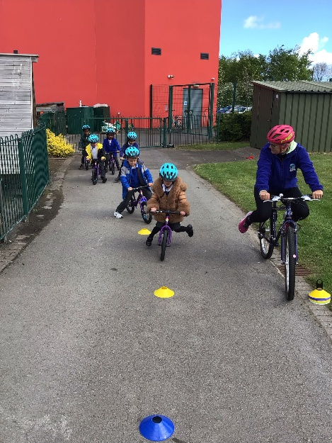
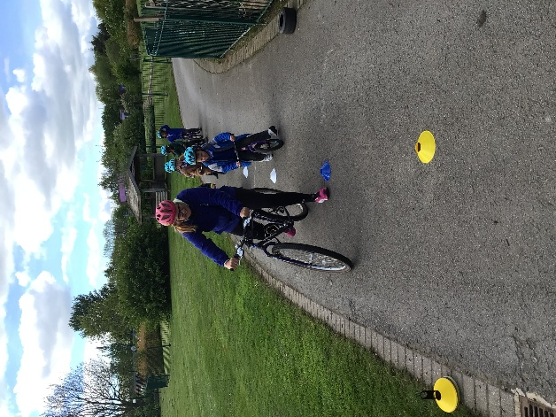

Early Reading
‘It is essential that, by the end of their primary education, all pupils are able to read fluently, and with confidence,’ English National Curriculum (DfE, 2013). At South Bank Primary, we believe all children can learn to read, whatever their background. reading is at the heart of our curriculum, and this is why we start our children’s reading journey in Nursery with a large focus on the development of their phonological awareness. This gives our children a firm foundation for starting Reception where children take part in daily discrete phonics sessions and weekly reading practise sessions. As a school, we follow the systematic synthetic programme Read Write Inc: Read Write Inc. Phonics - Ruth Miskin Literacy. Children are assessed regularly and placed into progress groups to ensure all children learn to read and write.

Forest School
Children in our Early Years have the exciting opportunity to learn in the great outdoors, whatever the weather to explore the natural environment. Forest School is delivered to ages 2 to 5 by a highly experienced member of our EYFS team who plans and delivers a learning programme that focuses on holistic development and growth in children. During their time at Forest School children build problem-solving skills, confidence, independence and resilience as they are allowed to test their limits in the natural world.
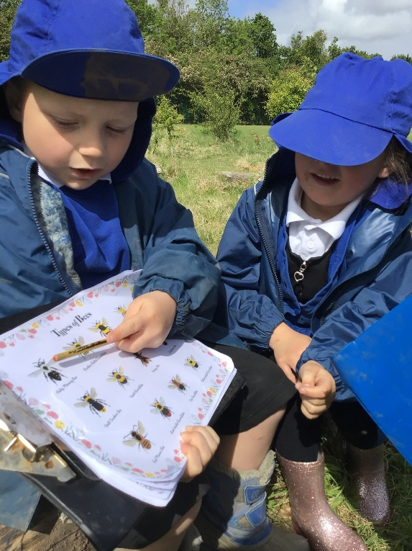
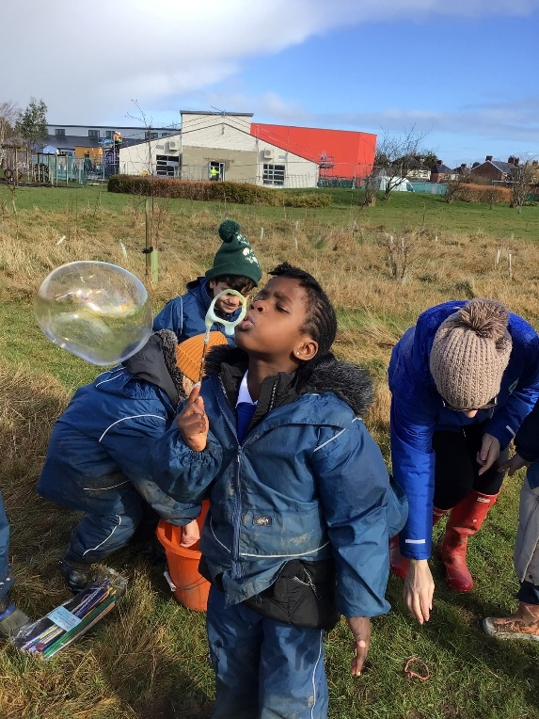

6. Assessment
The main EYFS assessment method is through practitioners’ observations of children in different teaching and learning contexts. Observations take place on a daily basis (both formally and informally). Adults will make spontaneous observations in order to capture significant moments of children’s learning. All practitioners are involved in observing children. Practitioners use observations to support their developing knowledge of individual children. Observations are evaluated, children’s learning priorities are identified, and relevant learning opportunities are planned to support children to make the next steps and progress. We use curriculum checkpoints to make judgements about each child’s level of development and input this data onto Sonar. We then assess each child’s level of development against the Early Learning Goals. Within the final term of the EYFS, we provide a written summary to parents, reporting their progress against the Early Learning Goals and indicate whether children are meeting expected levels of development, or not yet reaching expected levels (‘emerging’). This is the EYFS Profile.
7. Working with parents
Parents/carers are the child’s first and most enduring educators. When Parents/carers and practitioners work together in early years settings, the results have a positive impact on the child’s development. A successful partnership needs to be a two-way flow of information, knowledge and expertise. We aim to develop this by:
- Outlining how the EYFS is being delivered to Parents/carers during the new parents meeting in July, to enable them to understand the value of supporting their child’s learning at home and how they can access more information.
- Operating an “open door” policy, whereby parents/carers can come and discuss concerns and developments in an informal manner, and also to view children’s work.
- Sharing progress at school through the parent drop ins, ClassDoJo app, class webpages, Book and Breakfast and Forest School events.
- We offer the Early Words Together programme, developed by the National Literacy Trust, as a small parent and child group. This programme supports children’s communication, language and early literacy skills through shared activities such as stories, songs and conversation. It also helps parents to feel confident in supporting their child’s language development at home, strengthening the link between home and school.
- Each class has an email address for parents to share learning at home. The children then have the opportunity to share those moments with the rest of the class.
- Discussing individual next steps and progress with parents/carers at parents’ evening in Autumn and Spring terms and after their child has been a ‘focus child.’
- Any concerns over special needs will be discussed with parents and the Special Needs Co-ordinator (SENCO) for the school.
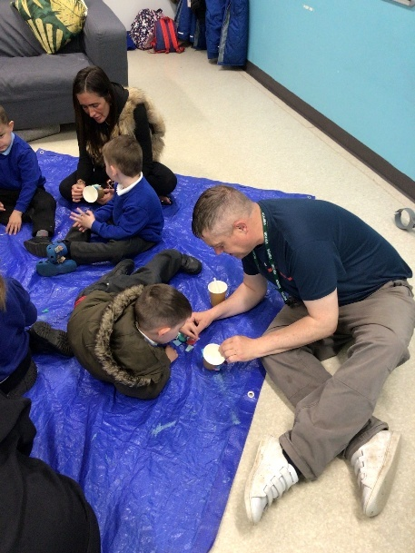
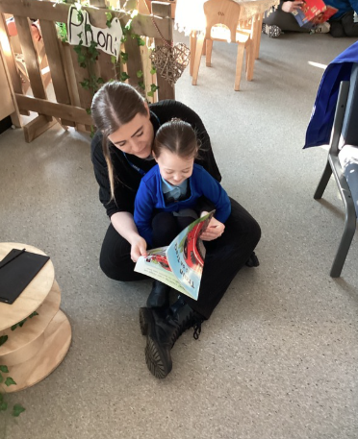

8. Safeguarding
‘Children learn best when they are healthy, safe and secure, when their individual needs are met, and when they have positive relationships with the adults caring for them.’ (Statutory Framework for EYFS 2025)
At South Bank Primary School, we understand that we are legally required to comply with welfare requirements as stated in the Statutory Framework for Early Years Foundation Stage 2025.
- To provide a setting that is welcoming, safe and stimulating where children can grow in confidence;
- Promote good health by following Early Years Foundation Stage nutrition guide 2025
- Manage behaviour effectively in a manner appropriate for the children’s stage of development and individual needs
- To ensure that all adults who look after the children, or who have unsupervised access to them, are suitable to do so;
- Ensure that the setting, furniture and equipment is safe and suitable for the purpose it was intended for;
- Maintain records, policies and procedures required for the safe efficient management of the setting and to meet the needs of the children.

Keeping Safe - It is important to us that all children in the school are ‘safe’. We aim to educate children on boundaries, rules and limits and to help them understand why they exist. We provide children with choices to help them develop this important life skill. We encourage children to take risks and highlight the importance of keeping themselves safe by teaching them how to recognise and avoid hazards. We aim to protect the physical and psychological well-being of all children. (See South Bank’s Safeguarding Children Policy).
Good Health - All children are provided with a healthy snack each day as well as being given the choice of milk. They have access to water at all times. Children brush their teeth daily and learn about how to keep their teeth clean.
Intimate Care - “Intimate” care is any care which involves washing, touching or carrying out an invasive procedure that most children are able to carry out themselves. However, depending on a child’s age and stage of development, they may need some support, for example dressing, wiping their bottom after using the toilet and changing underwear following an accident. In most cases, intimate care is to do with personal hygiene and it is good practise for the school to inform the school nurse of all children requiring intimate care.
Every child has the right to privacy, dignity and a professional approach from all staff when meeting their needs and it is important that staff work in partnership with parents to give the right support to an individual child. No intimate care is to given without the express written permission of the parent or guardian of that child and all parents and guardians will be asked to provide that permission when their child joins South Bank Primary Early Years Foundation Stage.

